Invoice Expert
New Computer
6/8/2012

Contents
Installing and Activating 2
Move your database to the new computer. 2

Installing and Activating
The installation of Invoice Expert on your new computer is the same process it was on your old computer. The activation although follows the same process you will need to de-activate your old installation code. When you login to your account only you will see your old serial number. To the right of it you will see the de-activation option.

Move your database to the new computer.
Invoice Expert database is stored in a single file called PCInvXE.vdb3, by default this file is stored in your data store on your computer. The easiest way to determine location of your database is to open Invoice Expert and check the path being displayed on the bottom right corner, as shown below.
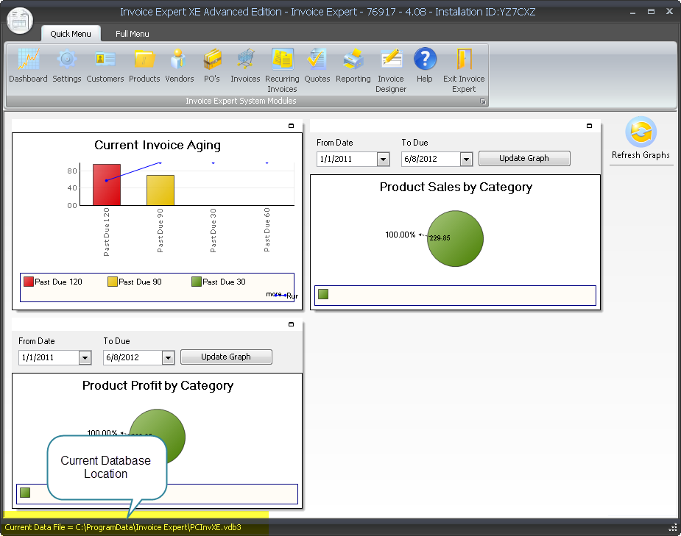
Once you have identified the location of your database you need to back it up to an external drive so that it can be copied to your new computer.
NOTE: On the new computer you might want to create a new folder under your my documents and save it there.
Now that you have the database on the new computer you need to connect to it. In Invoice Expert click on the “Full Menu” then click on “Switch Companies”. This will display the following screen.
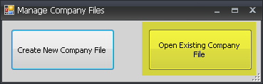
From here click on Open Existing Company File, this will allow you to navigate to your old database and open it. Once you have selected the file Invoice Expert will close and then re-open attached to your old database.

